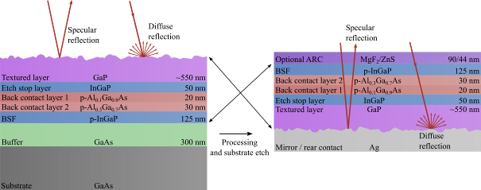

Figure 1: Schematic representation of the layer structures used in temperature and growth time optimizations (Luc’s data). Top side reflection (left) and backside reflection (right) measurements. Backside reflection can be done with or without ARC

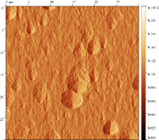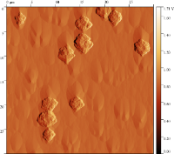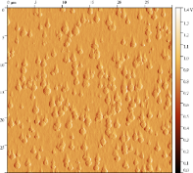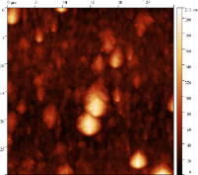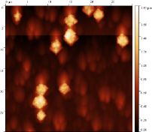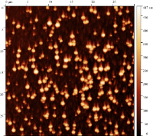

**650 °C, 10 minutes**

**700 °C, 10 minutes**

**730 °C, 10 minutes**

**Rq A = 91.72 nm  
Rq B = 16.31 nm**

**Rq A = 253.10 nm  
Rq B = 108.60 nm**

**Rq A = 26.64 nm  
Rq B = 14.54 nm**

Figure 2: Height and amplitude AFM images of GaP surfaces grown for 10 minutes at 650, 700 and 730 degrees.

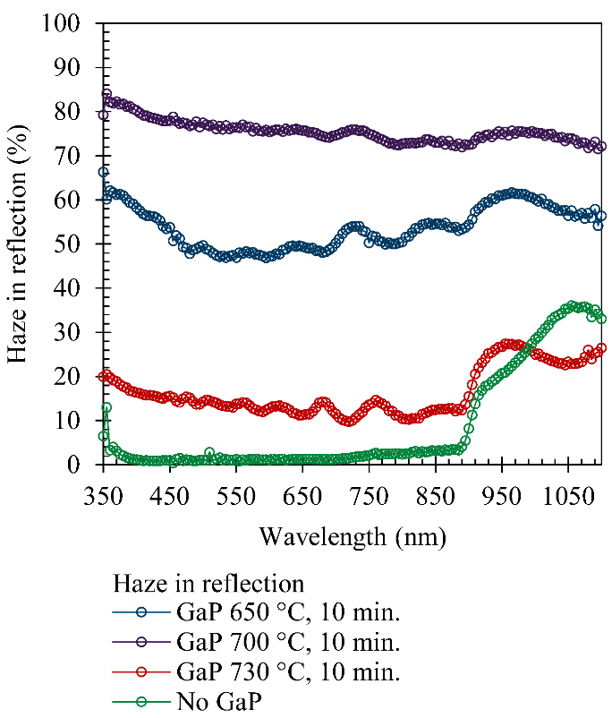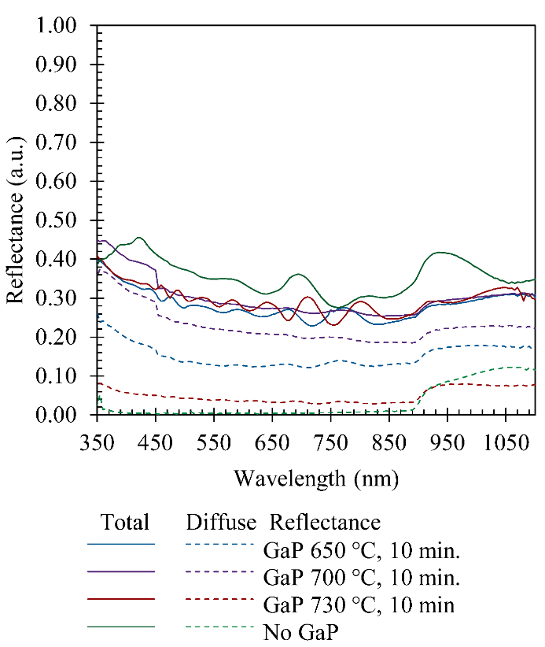

Figure 3:Top side reflection and Haze of GaP surfaces grown for 10 minutes at 650, 700 and 730 degrees

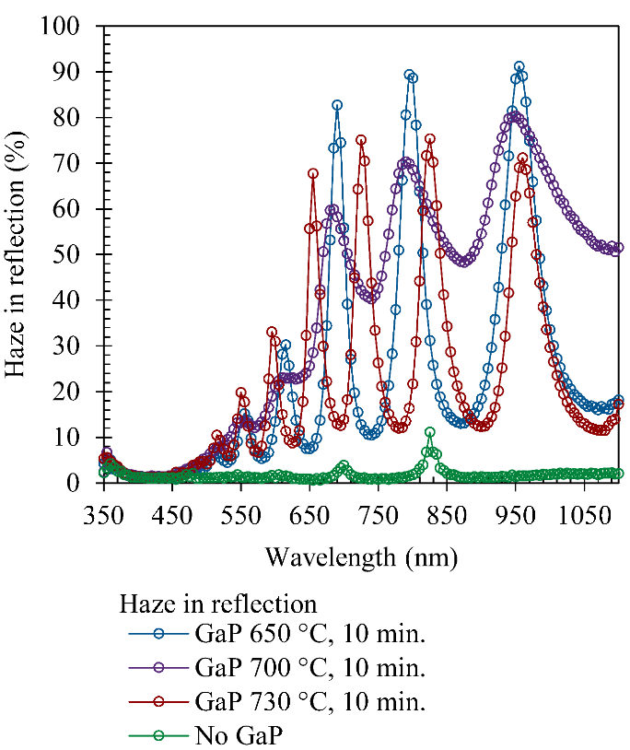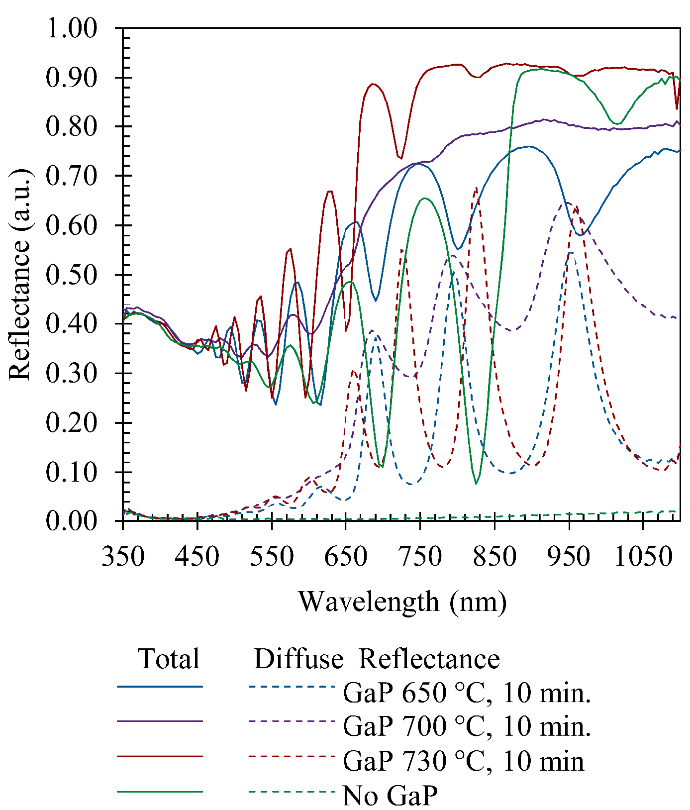

**(a)**

**(b)**

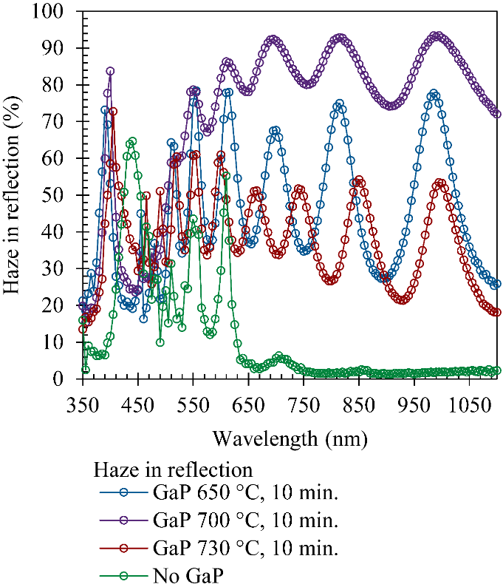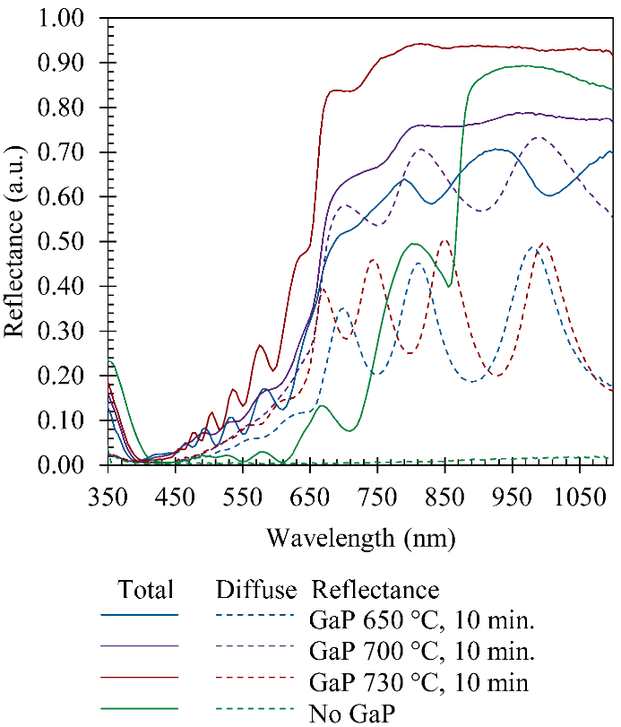

**(c)**

**(d)**

Figure : Backside reflection and Haze of the inverted GaP surface covered with Ag ay 650, 700 and 730. A) and b) without ARC, c) and d) with ARC.

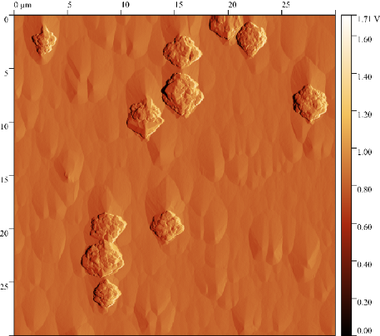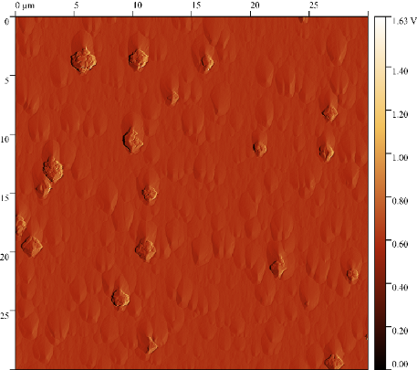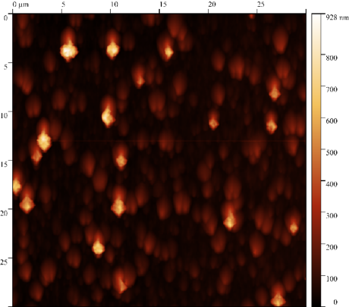

**(a)**

**(c)**

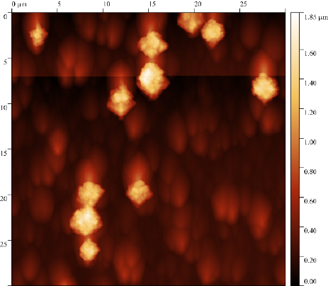

**(b)**

**(d)**

**700 °C, 5 minutes**

**700 °C, 10 minutes**

**Rq A = 86.52 nm  
Rq B = 47.81 nm**

**Rq A = 253.10 nm  
Rq B = 108.60 nm**

Figure : AFM height and amplitude map for GaP surfaces grown at 700 degrees for 5 and 10 minutes.

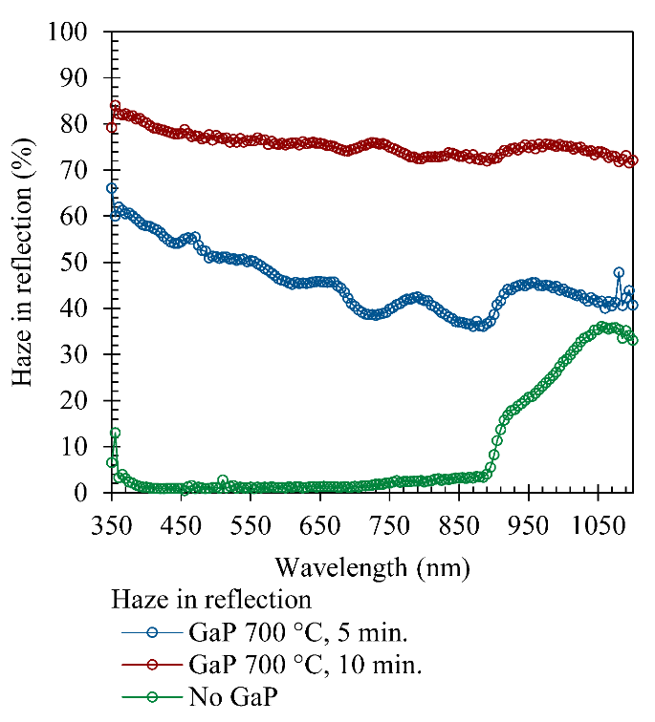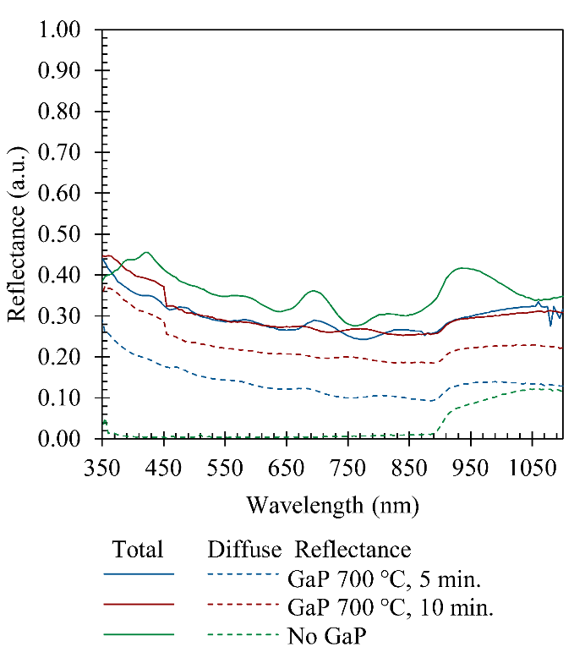

**(a)**

**(b)**

Figure 6: Top side reflectance and Haze of planar and GaP surfaces grown at 700 degrees for 5 and 10 minutes.

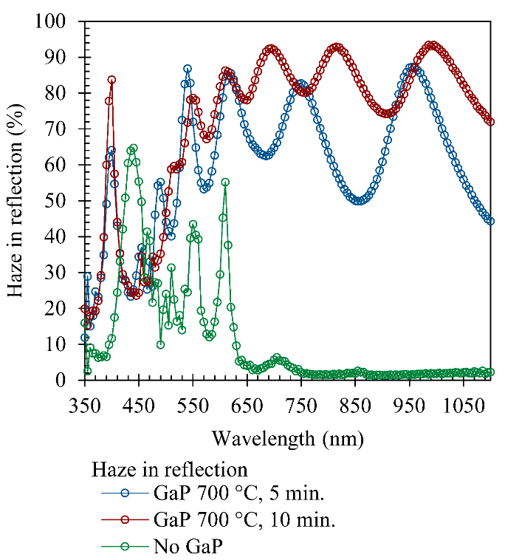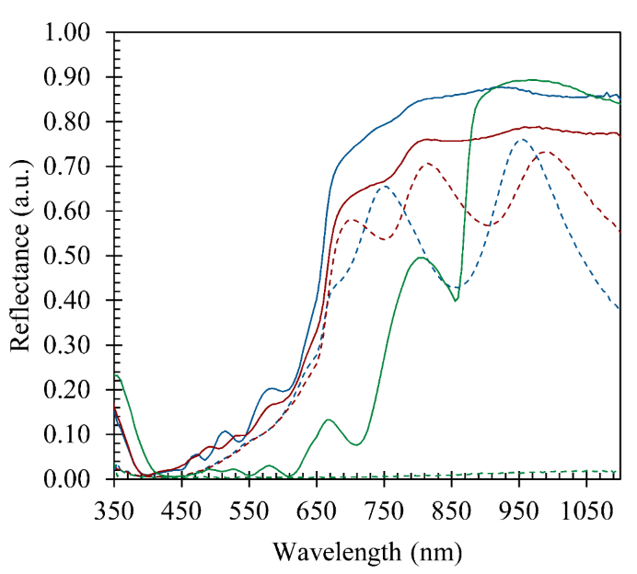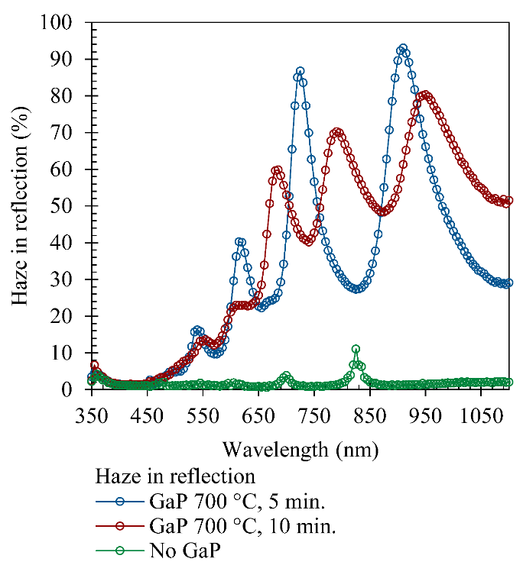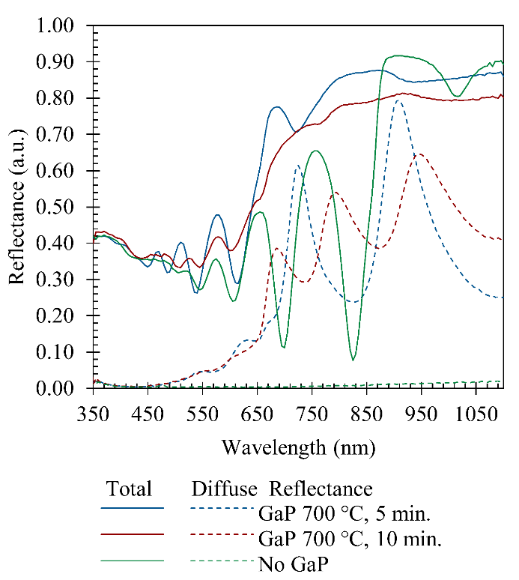

**(a)**

**(b)**

**(c)**

**(d)**

Figure 7: Backside reflectance and Haze of planar and GaP surfaces grown at 700 degrees for 5 and 10 minutes. a) and b) without ARC, c) and d) with ARC.

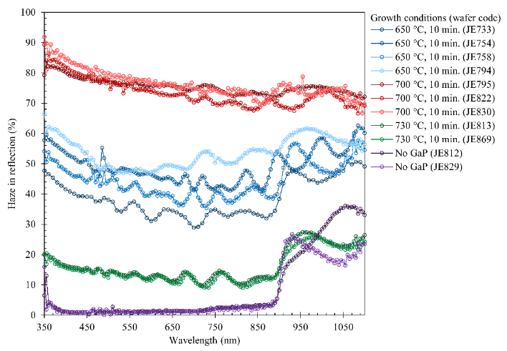

Figure 8: Haze of from the topside of every GaP surface, grown at 650, 700 and 730. Image shows the reproducibility of lattice mismatched GaP grown by MOCVD.

|  |  |  |
| --- | --- | --- |
| **Average Haze in reflection Top surface** | | |
|  | **Wavelength range** | |
| **Growth conditions (wafer code)** | **350 – 1100 nm** | **350 – 900 nm** |
| 650 °C, 10 min. (JE733) | 39% | 36% |
| 650 °C, 10 min. (JE754) | 49% | 47% |
| 650 °C, 10 min. (JE758) | 45% | 42% |
| 650 °C, 10 min. (JE794) | 54% | 52% |
| 700 °C, 10 min. (JE795) | 76% | 76% |
| 700 °C, 10 min. (JE822) | 73% | 74% |
| 700 °C, 10 min. (JE830) | 76% | 77% |
| 730 °C, 10 min. (JE813) | 16% | 14% |
| 730 °C, 10 min. (JE869) | 16% | 13% |
| No GaP (JE812) | 2% | 2% |
| No GaP (JE829) | 7% | 2% |

f)

e)

d)

c)

b)

a)

Figure : DICM images of GaP surfaces grown on InGaP/AlGaAs/InGaP on 6deg off GaAs wafer at 700 degrees. Growth run was terminated at 10s (a), 1 min (b), 4 min (c), 7 min (d) and the 10 minutes (e) benchmark. F) shows an AFM image of the “cauliflower” structures that arise after 4 minutes of growth.

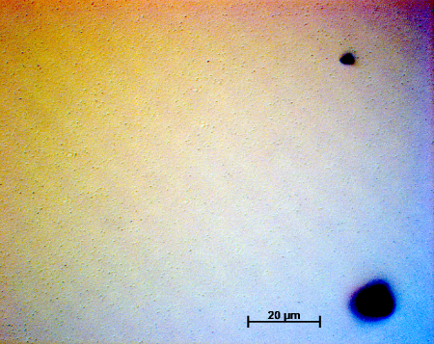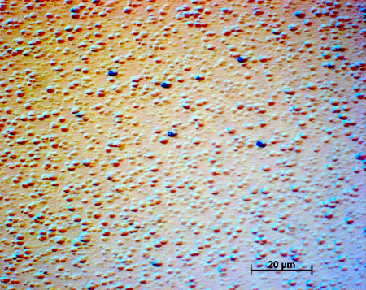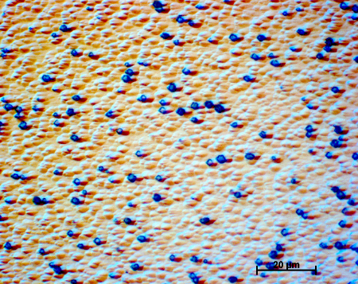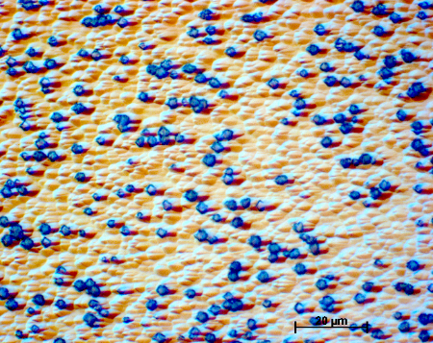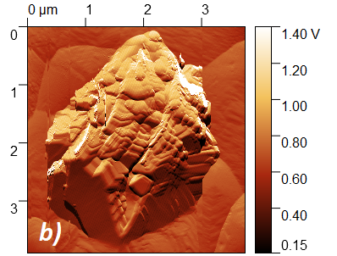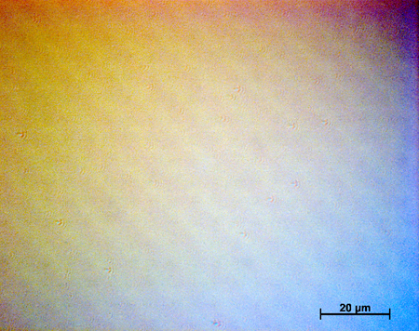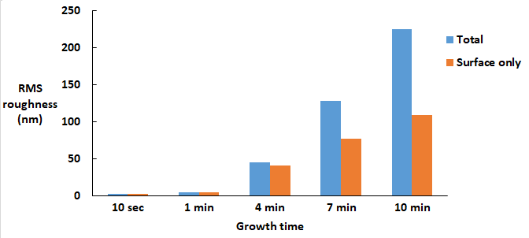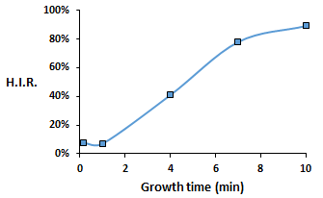

Figure : Roughness (left) and haze (right) for GaP surfaces grown with different growth times.

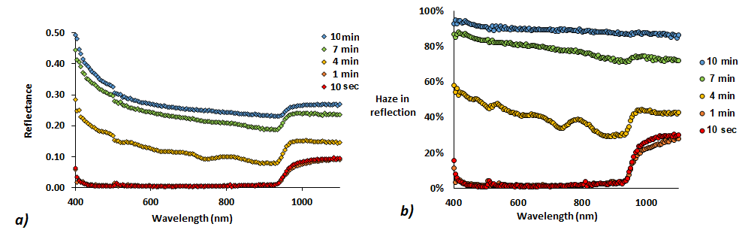

Figure : Top side reflection and haze for GaP surfaces grown with different growth times. Reflection is the total, diffuse is also available off course

Figure : DICM and AFM of GaP surface grown for 2 min at 650 degrees followed by a linear temp ramp to 700 for 8 minutes .

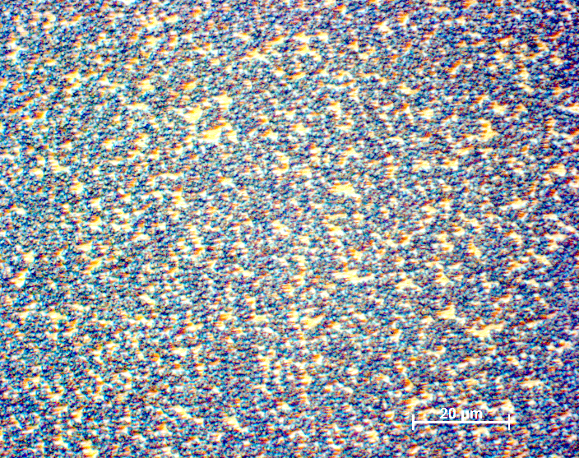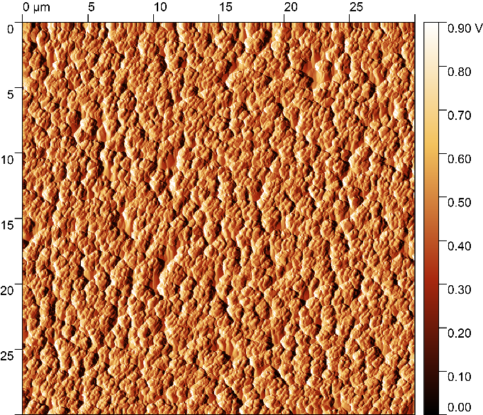

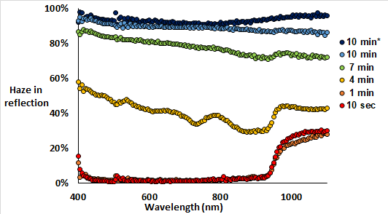

Figure : Haze of GaP surface grown for 2 min at 650 degrees followed by a linear temp ramp to 700 for 8 minutes